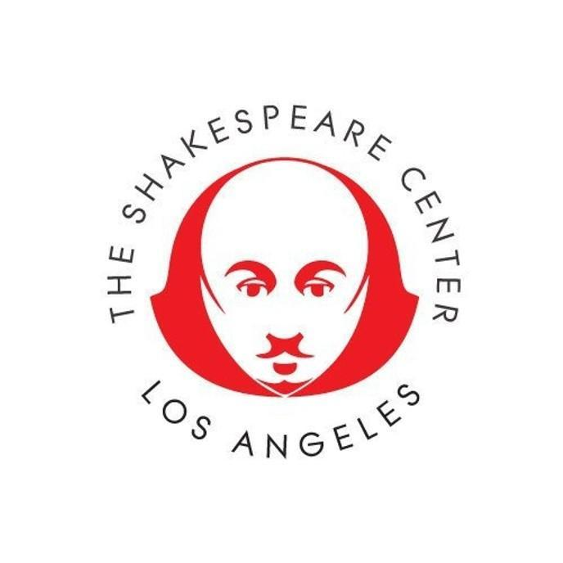
Contact: Davidson & Choy Publicity
Victoria Westbrook v.westbrook@dcpublicity.com 704-340-5906
The Shakespeare Center LA

The Shakespeare Center LA Breaks New Ground
with AI Integration of Art and Education

LAUSD Students and Teachers to Converse with Dr. Victor Frankenstein’s AI Creature Live, Online, and in Real Time!

January 13 -16, 2025
More Information at tempestla.org

Los Angeles, CA - Reflecting iconic media theorist Marshall McLuhan’s 1964 adage “the medium is the message,” The Shakespeare Center of Los Angeles, recently awarded for its groundbreaking immersive production of Shakespeare’s The Tempest, continues its commitment to innovative storytelling and high-quality art in education with AI Frankenstein.

From January 13-16, hundreds of Los Angeles Unified School District students and teachers will get under the skin of Dr. Victor Frankenstein’s AI Creature. Engaging the AI Creature in live, real time interactive e-conversations, high school classrooms become a laboratory for beta testing the educational impact of integrating advanced cutting-edge AI chatbot technology with classic literature, storytelling, and learning.

The Shakespeare Center is collaborating with Alice Scope, an international field-leading new media art curator and cultural strategist to explore the integration of highly advanced artificially intelligent chatbot technology with classic storytelling practices to explore new ways for art to engage students and teachers.

After classroom conversations with the AI Creature student engagement with R.N. Sandberg’s one-act adaptation of Frankenstein, will be offered by a union-contracted young professional company of actors, a stage manager, director, and a producer drawn from the California Institute for the Arts School of Theater.

“Our commitment to timeless stories told in timely ways with an emerging generation of well-trained storytellers compels multi-sensory, multi-media interactive expression. Our patrons, students, and art-makers are growing increasingly disinterested in invitations to sit passively in a dark room on the receiving end of an audio and visual experience,” observes Shakespeare Center Artistic Director Ben Donenberg, “The viability of our art form and marketplace demands immersive innovation and change capital.”

Underscoring a forward-thinking response to the shifting storytelling landscape, Shakespeare Center is transforming its traditional 13,000 square foot black box into a 22,000 square foot multi-media story space.

The reimagined venue is designed by internationally acclaimed architect Zoltan Pali to support the fusion of live story performance with new technologies that deepen The Shakespeare Center’s forty-year commitment to illuminating what it means to be creative and human.

Last year, The Shakespeare Center’s commitment to excellent art in education featured Al Pacino and a high-profile cast touring Southern California high schools with a student participatory reading series of Shakespeare’s Richard the Third.

Additionally, Shakespeare Center is midway through a five-year, $2 million Shakespeare and Social Justice curriculum development initiative funded by the U.S. Department of Education’s Assistance for Arts Education program.

This year, in collaboration with Venturous Theater Fund and The Svanda Theater located in Prague’s Smichov District, The Shakespeare Center is developing a fresh adaptation of Czech playwright Karel Čapek’s 1921 epic science fiction creation R.U.R., which gave the world the word “robot.”

Playwright Talene Monahon and director Jess Chayes spearhead The Shakespeare Center’s commission and international culture exchange with Prague’s Daniel Hrbek, artistic director of The Svanda Theater.

Ben Donenberg is the Founder and Artistic Director of The Shakespeare Center of Los Angeles (SCLA). As a director of populist interpretations of Shakespeare, Ben has built a reputation of creating excellent, accessible productions that are underscored by the canons of modern songwriters and recording artists. His production of Much Ado About Nothing at Center Theatre Group starred Helen Hunt and Tom Irwin and featured Lyle Lovett in the role of the musician Balthasar. The production was supported by progressive bluegrass singers and songwriters Sean and Sara Watkins.
Other Shakespeare productions include two productions of A Midsummer Night’s Dream. One featured Natalie Cole and Obba Babatundé singing Nat King Cole jazz standards, with text performed by Tom Hanks, William Shatner, Tracey Ullman, Geoffrey Rush, Christina Applegate, Rita Wilson, Zack Braff, and Kate Hudson (2006, SCLA). Ben directed the other for a Los Angeles Philharmonic’s 1999 Fall Gala at the Dorothy Chandler Pavilion. Conducted by Esa-Pekka Salonen, it featured Mendelssohn’s Incidental Music for A Midsummer Night’s Dream and was supported by voices from the Los Angeles Opera and Los Angeles Master Chorale with text performed by Alfre Woodard, David Ogden Stiers, and Peter MacNichol. Other actors and recording stars who have performed in Ben’s annual staging of Shakespeare include Sir Paul McCartney, Paul Simon, Sir Anthony Hopkins, Al Pacino, Kenneth Branagh, Will Smith, Steve Martin, Cedric the Entertainer, Dule Hill, Billy Crystal, Robin Williams, Martin Short, Reba McEntire, Faith Hill, Tim McGraw, Ewan McGregor, Jackson Browne, Tracy Ullman, and Eric Idle.
Ben’s production of The Merry Wives of Windsor at UCLA’s Royce Hall featured the songs of Hank Williams performed by Reba McEntire, with text performed by Kenneth Branagh, Tom Hanks, Tracey Ullman, Rita Wilson, Martin Short, and William Shatner, who played Falstaff. His presentation of As You Like It also featured Lyle Lovett, this time singing the music of Pete Seeger, with text performed by Sir Anthony Hopkins, Benjamin Bratt, and Carla Gugino. Ben’s Twelfth Night featured Peter Gallagher singing Gershwin and his The Two Gentlemen of Verona featured music by The Beatles. Ben has also directed more traditional outdoor and site-specific Shakespeare plays for SCLA that have toured to venues throughout Los Angeles County, including to Union Station, Pershing Square, the Cathedral of Our Lady of the Angels, and the South Coast Botanic Garden.
Ben has received local awards and national recognition from Actors’ Equity Association, NAACP, Los Angeles Drama Critics Circle, California Educational Theatre Association, and the Mayor of Los Angeles. His 2006 six-year Presidential appointment to the National Council on the Arts was unanimously approved by the United States Senate. In 2012, Ben was selected by the U.S. Secretary of Defense to participate in the U.S. Department of Defense Joint Civilian Orientation Conference. He has lectured on theatre aesthetics at the University of Southern California, and at the Huntington Library and SCLA’s award-winning Will Power teacher training seminars. Ben received his bachelor’s in philosophy from University of Southern California and is a graduate of The Juilliard School’s Drama Division.
The Shakespeare Center LA
The mission of The Shakespeare Center LA is to ignite personal and community transformation. By producing world-class theatrical productions, providing best practices high-quality arts education experiences, and offering national award-winning arts-based workforce development programs targeting under-served youth and veterans, The Shakespeare Center of Los Angeles demonstrates that excellent accessible immersive arts engagement builds community and changes lives. Learn more at https://www.shakespearecenter.org/

# # #

